Application note 008

Beginner’s guide to calculate programmed sums, demonstrated with Ramanujan’s famous series for the inverse of 𝝿, and the C47 Σ_{n} function:

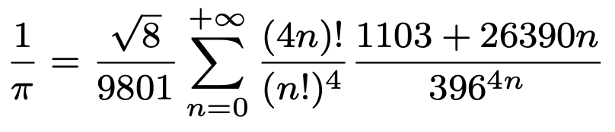
S. Ramanujan * Repeating/iterative section

Start by setting up the repeating C47 RPN program for the sum (the keystrokes are detailed in the annexure below):

Create a new program “SR”, the iterative section of the Ramanujan series:
Create new program: g[GTO].. f[PRGM]
Label it: g[LBL] 𝑎 S R [ENTER]

Now create the RPN function: (Tip: When using the programmed sum function, for each internal iteration the stack will be pre-filled with n, allowing extensive RPN stack manipulation with x⇄, y⇄, z⇄, t⇄, x⇄y, RCL T, etc.).

Enter it: 4 × [x!] [x⇄y]
[x!] 4 [y^{x}] ÷ [x⇄y]
4 × 396 [x⇄y] [y^{x}] ÷ [x⇄y]
26390 × 1103 + ×
[RTN]
Program listing:

C47 Program file export: Export format version 2, C47 program version 1.
0000: { Prgm #42: 56 bytes / 24 steps }

0001: LBL 'SR'
0002: 4
0003: *
0004: X!
0005: X<>Y
0006: X!
0007: 4
0008: Y^X
0009: /
0010: X<>Y
0011: 4
0012: *
0013: 396
0014: X<>Y
0015: Y^X
0016: /
0017: X<>Y
0018: 26 390
0019: *
0020: 1 103
0021: +
0022: *
0023: RTN
0024: END

Since clearly the C47 cannot and should not do infinite iterations of this sum ;-) we need to determine how many iterations are needed for the accuracy required, but let’s first do the example below for N = 12, then do more targeted analysis later:

Do the programmed sum as follows: From 0 to 12 in steps of 1, do Σ_{n} as follows:

Programmed sum: 0 [ENTER] 12 [ENTER] 1 [Σ_{n}] ‘SR’

Tip: find [Σ_{n}] on the [ADV] menu: 

The result on the stack, is the programmed sum for the first 13 terms:

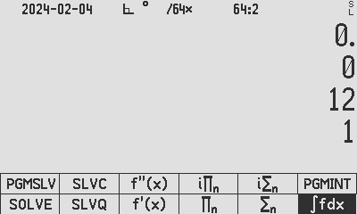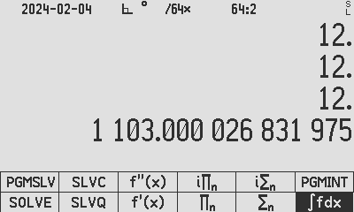
Ready to execute Σ_{n} After execution of Σ_{n}

After completing Ramanujan’s formula: 8 [√x] × 9801 ÷ [1/x], the result seems very close to 𝝿.

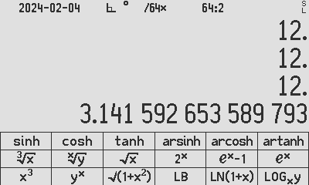
Ramanujan’s result

To determine the distance from the built-in 34-digit 𝝿, we subtract 𝝿 from our Ramanujan result with the result of 0. indicating that the 13 terms used resulted in the same accuracy as our stored 𝝿 constant.

An interesting question is what is the minimum number of terms needed for the Ramanujan series to be accurate to compare with the internal C47 rendition of 𝝿?

An intuitive inspection of the formula reveals that we are dealing with the largest factors being (4n)! and 396^{4n}. Noting that precision is maintained to 34 digits on C47, it can be deduced that for the factor (4n)!, (4x12)! > 1×10³⁴ could be a limit, and for 396^{4n}, 396^{4x4} > 1×10³⁴ could be a limit. This suggests that values of n, where n > 4 could result in programmed sum increments that cannot be registered in our 34-digit C47 floating point precision.

To check this hypothesis, we can do this procedure for multiple values of n to verify how many terms are needed for the accuracy level required, and to do this comfortably, we can make a second program, to sequence the previous programmed sum steps as follows:

Make a new program called SRSEQ which will calculate the programmed sum for 0 to n, complete the Ramanujan formula to obtain for Ramanujan’s 𝝿 (which I call R(𝝿)) below, and subtract the C47 𝝿 constant from it, resulting in: R(𝝿) - C47(𝝿) in X. This new program is will be used in the form “n SRSEQ” which will result in a single accuracy figure remaining in X:

Create a new program “SRSEQ”, to sequence the previous “Sum of SR” Ramanujan series:
Create New program: g[GTO].. f[PRGM]
Label it: g[LBL] 𝑎 S R S E Q [ENTER]
Enter it: 0 [STO] Z [R↓] 1 [Σ_{n}] ‘SR’ 8 √x × 9801 ÷ [1/x] 𝝿 - f[PRGM]
Run it: 3 [XEQ] [PROG] [SRSEQ]

C47 Program file export: Export format version 2, C47 program version 1.
0000: { Prgm #44: 44 bytes / 15 steps }
0001: LBL 'SRSEQ'
0002: 0
0003: STO Z
0004: Rv
0005: 1
0006: SUMn 'SR'
0007: 8
0008: SQRT
0009: *
0010: 9 801
0011: /
0012: 1/X
0013: PI
0014: -
0015: .END.

This shows that the accuracy that the Ramanujan 𝝿 converges extremely fast to 𝝿:
N | Terms | Proximity to 𝝿 = [ 1 / (SR(N) × √8 / 9801) ] - 𝝿
0 SRSEQ | 1 | 7.6423512421851352805745713E-8
1 SRSEQ | 2 | 6.39536262443026511E-16
2 SRSEQ | 3 | 5.682423256E-24
3 SRSEQ | 4 | 5.1E-32
4 SRSEQ | 5 | 0.

It is shown in the table that the initial guess of n > 4, sufficiently converges to 34 digits accuracy.

Detailed keystrokes to make a new program & label it:

g[GTO].. f[PRGM] | 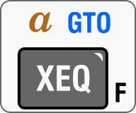
g[LBL] 𝑎 SR [ENTER] | 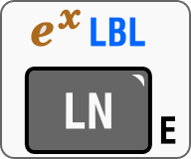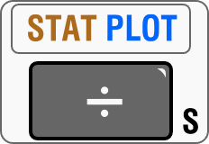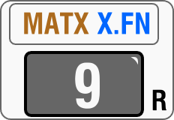

Detailed keystrokes to enter the “SR” program:

4 × [x!] [x⇄y] | 4   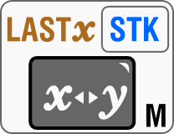
[x!] 4 [y^{x}] ÷ [x⇄y] |  4 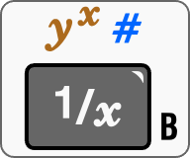  
4 × 396 [x⇄y] [y^{x}] ÷ [x⇄y] | 4  396    
26390 × 1103 + × | 26390  1103 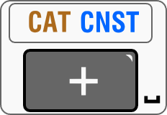 
[RTN] | 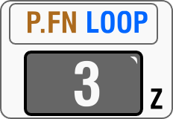

Detailed keystrokes to enter the “SRSEQ” program (after SRSEQ created in PRGM mode):

0 [STO] Z [R↓] 1 [Σ_{n}] ‘SR’ | 0 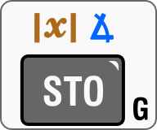 Z 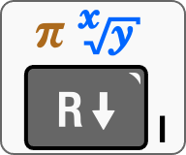 1  PROG ‘SR’
8 √x × 9801 ÷ [1/x] | 8 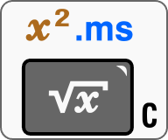  9801   𝝿 -
f[PRGM] | 

Executing a program SRSEQ:
3 [XEQ] [PROG] [SRSEQ] | 3  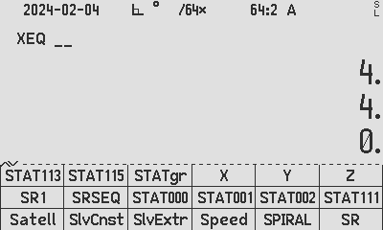

* Source for the example: Ramanujan, as discussed here: https://arxiv.org/pdf/2104.12412.pdf

Author Jaco Mostert

Copyright (C) 2024 The C47 Development Team. Permission is granted to copy, distribute and/or modify this document under the terms of the GNU Free Documentation License, Version 1.3 or any later version published by the Free Software Foundation; with no Invariant Sections, no Front-Cover Texts, and no Back-Cover Texts. A copy of the license can be downloaded from gnu.org.

